Colin Quinn

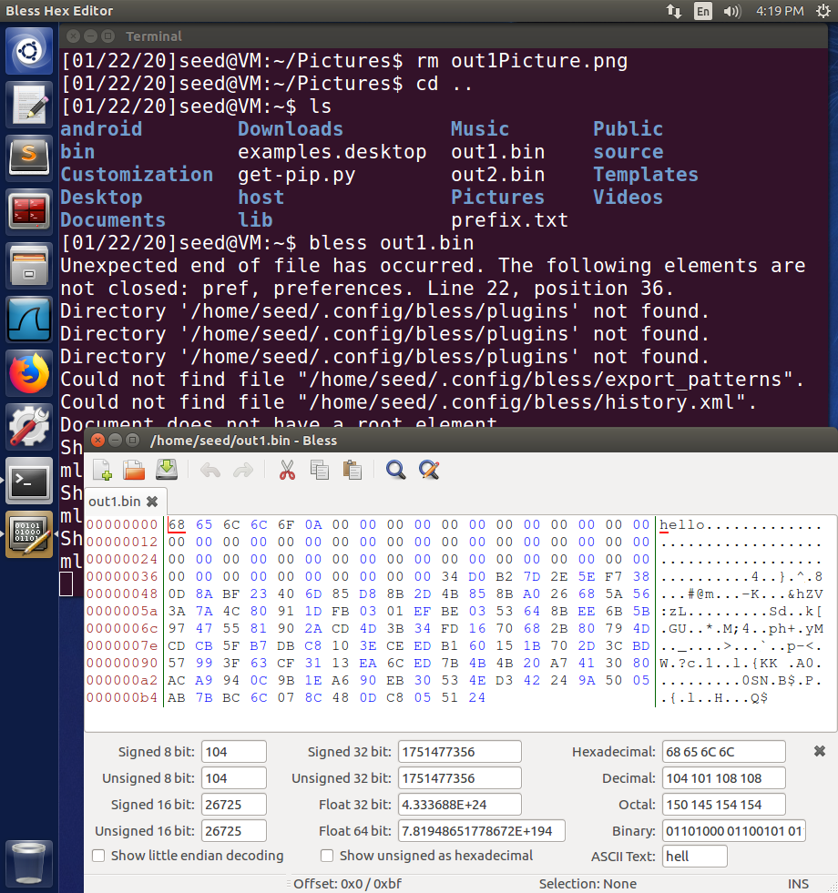

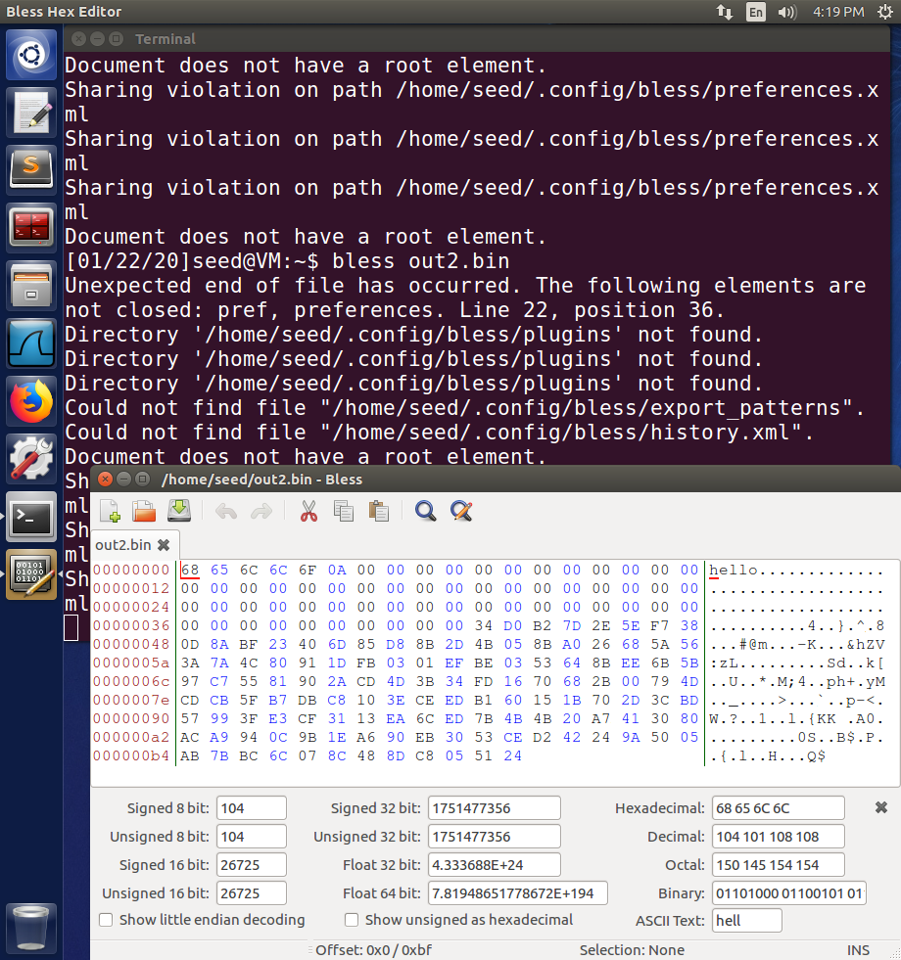

1. If the length of prefix.txt is not a multiple of 64, then there will be padding characters added so that it meets 64, 128, 256…

3. There are slight differences in the hashes of the 64 byte version, despite being the same text within the file used to generate the hashes.

